Signing up for water/sewer/trash service at Town Hall
Prior to establishing water service, you will need to submit the following information to Town Hall:
- Application (available at Town Hall and on our website)
- Driver’s License
- Lease Agreement (if renting)
*We accept check, cash, money order, and credit card for all payments.
Please be advised that we require 48-hour notice prior to turning water on/off.

Garbage and Recycling
Garbage collection is Monday and Friday for Residential customers, and Monday, Wednesday, and Friday for Heavy Commercial customers. Recycling for Residential customers is Wednesday. Recycling for Heavy Commercial customers is Tuesday. Garbage should be set out by 7:00 a.m. in cans no larger than 20 gallons with tight fitting lids.

Special Pick-Ups
For special pick-up (any trash other than ordinary household garbage) please contact our billing department at 304-876-2574.

Spring and Fall Clean-Up
The Corporation of Shepherdstown provides a Spring and Fall clean-up each year. For questions, please contact Town Hall at 304-876-2312.

Shepherdstown Welcomes You!
Historic Shepherdstown, the oldest town in the state of West Virginia, nestled in the lower Shenandoah Valley - is only 90 minutes from the Washington-Baltimore metropolitan areas but miles away from the stress and rushed lifestyle of the city. Stroll along German Street, filled with more than a dozen fine dining and casual restaurants, and unique locally owned shops. You're sure to find the perfect spot to stay, eat and shop here, and, of course, to see a parade - all uniquely Shepherdstown. Commuters: Marc Train is 3 miles from Shepherdstown

Shepherdstown Town Hall
Ph. 304-876-2312
Fax: 304-876-1473

Website: www.shepherdstown.us

Located on 2nd floor - Receptionist, Town Clerk, Billing Clerk, Planning/Zoning Officer, and the Mayor’s Office.
Hours: M-F 8:00 a.m. – 4:30 p.m.

Town Council: Mayor - Jim Auxer, Recorder - Lori Robertson, Town Council - Wanda Grantham Smith, Bane Schill, Karene Motivans, David Rosen & Jim Ford.

Corporation
of
Shepherdstown
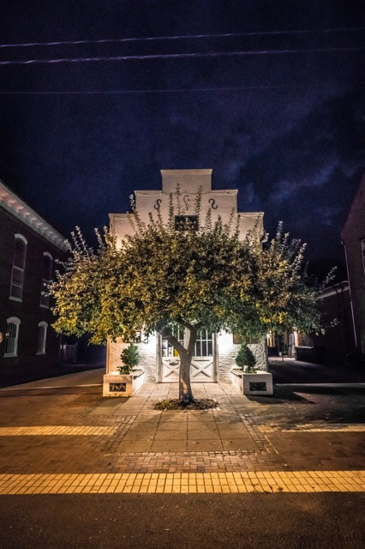
Photo Credit: Scott McKibben
www.byscottmckibben.com

104 North King Street
P.O. Box 248
Shepherdstown, WV 25443
Business Licenses
Any business operating in Town must obtain a business license. Contact the Town Clerk for more info.

Parking Information
Parking meters are enforced Monday through Friday from 8 am until 6 pm. Meters are not enforced on Saturday or Sunday or on legal holidays.
Meters – coins or Passport
App @ https://ppprk.com/park/
**Residential parking zones are enforced 24/7
Parking tickets can be paid via drop-box located outside of Town Hall. We accept cash/check/credit card.
See enclosed parking meter map

Parks
Park Hours: dawn to dusk-map enclosed

Planning/Historic Landmarks Commissions
Those wishing to add/change the appearance or building materials to a building’s exterior, including storage sheds/garages, fencing, signage, decks, railings, painting, walkways, lighting, handicap ramps, etc. must contact the Planning/Zoning Officer for guidance.

Police Department
Office hours: Monday – Friday, 8:00 a.m. to 4:00 p.m. After hours call 911
First floor of Town Hall
Business Office: 304-876-6036
Chief of Police: Mike King
Ph. 304-876-6037

Sidewalks –repairs
Property owners are responsible for the sidewalks adjacent to their property. See the sidewalk ordinance for more info.

Snow Removal Policy
Property owners and renters - policy regarding snow removal on sidewalks.
Section 11-407 Prohibited accumulations of snow, ice and debris on sidewalks and removal thereof by town at expense of property owners provides that…..
No person shall permit the accumulation of snow or ice upon the sidewalk adjacent to any property owned or occupied by him/her within the town, but shall remove the same within a reasonable time not later than 9:00 a.m., and 4:00 p.m., each day that snow or ice accumulates thereon.

Trees
Town Tree Maintenance Request Forms are available at Town Hall. Emergency call 911, if not-304-876-2312. It is against town ordinance to cut a tree down on town property. For a copy of appropriate trees to plant in town, see receptionist.

Mail – delivered to Post Office only
Newspapers – The Shepherdstown Chronicle, The Journal, The Spirit, The Herald-Mail, and The Good Newspaper.
Local TV – WHAG (Hagerstown)
Shepherd University Radio – WSHC 89.7 FM

Find us on facebook at Shepherdstown, West Virginia

Phone Directory & Services

Town Hall Contacts:
Accounting Clerk 304-876-2589
Billing Clerk 304-876-2574
(water/garbage/recycling billing)
Mayor’s Office 304-876-2605
Receptionist 304-876-2312
(emergency alert sign up/apply for & pay utilities/event-tree request forms)
Town Clerk 304-876-2398
(town administration)
Planning/Zoning Dept. 304-876-6858
(business & homeowners/sign/fences/exterior building questions)

Police Department Contacts:
Police Department 304-876-6036
(parking stickers/tickets
Non-Emergencies 304-725-8484
Police/Fire Emergencies 911

Corporation-Misc. Contacts:
Public Works 304-876-3322
Waste Water Dept. 304-876-3350
Water Dept. 304-876-2394
(water leaks)
Visitor’s Center 304-876-2786
www.ShepherdstownVisitorsCenter.com
(info/brochures/parking map)
Library 304-876-2783
www.lib.shepherdstown.wv.us
Post Office 304-876-2370
Shepherdstown Day Care - 304-876-6923
Voting place –Local (Town Hall) Co/State/National (Trinity Church)

County Contacts:
DMV – 304-558-3900 –
25 Rudland Rd, Kearneysville
County – Jefferson County Seat - Charles Town
Jefferson Co. Assessor’s Office – 304-728-3215,
100 E. Washington St –Charles Town
Voter registration – 304-728-3246
104 E. Washington St – Charles Town

